Northrop Frye

Frye is another New Critic who admirably shows the potential of the school by attempting to do for literature what Linaeus did for biology, namely, to provide a complete taxonomy. He starts with the most basic element of literature: the symbol, which he defines as any unit of literary structure which can be isolated for attention.
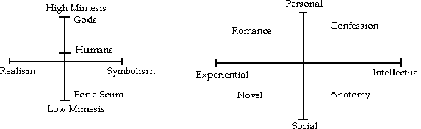
He divides literature up into the elements of Description, Image, Archetype and Monad (the entirety of human life contained in one work of art, such as scripture), and each of these elements is characterized by a tension between two forces, and each work can be placed somewhere on a spectrum between these two. Thus any description can be placed on a scale ranging from the outward 'sign' to the inward 'motif,' any image is between naive allegory and paradoxical private association, any archetype ranges from naked to concealed (Jean-Claude VanDamme to Madame Bovary), and monads range from fundamentalism to symbolism.
Frye also uses two double-axis charts to explain literature:

So, any work can be charted somewhere on both of these charts, based either on what is being imitated or the aims and sources of the work.
It is fairly easy to tell from this that Frye was suffering from a bit of "science-envy." Contemporary readers of Frye tend to be rather critical of him for the naiveté with which he accepts the elevation of science in our culture. Nevertheless, his was an ambitious project, and not one we can ignore.

